**Tutorial No. 3**

**Problem statement:**

**Design Assumptions:**

**Design Diagrams:**

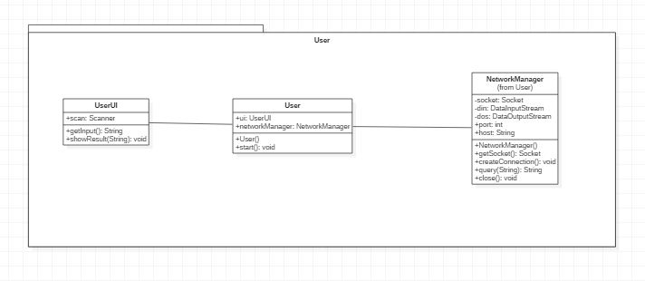

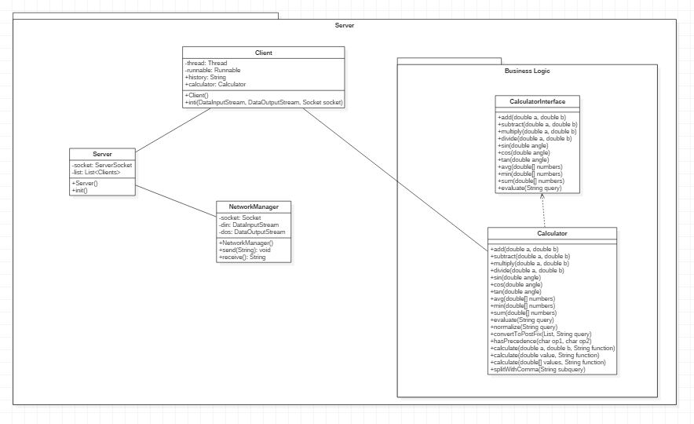

**Code:**

**server side**

**ClientHandler.java**

************************************************************************

package com.mangnaik.yogesh.server;

import com.mangnaik.yogesh.calculator.Calculator;

import com.mangnaik.yogesh.networkmanager.NetworkManagerServer;

import java.net.Socket;

/**

* Created by Yogesh on 2/2/2018.

*/

class ClientHandler {

private Thread thread;

private Runnable runnable;

private String history;

private Calculator calculator;

ClientHandler(Socket socket) {

init(socket);

}

private void init(Socket socket){

NetworkManagerServer networkManager = new NetworkManagerServer(socket);

calculator = new Calculator();

history = "";

runnable = () -> {

while (true) {

System.out.println("ClientHandler is receiving");

String query = networkManager.listen();

System.out.println(query);

double answer = calculator.evaluate(query);

networkManager.send(answer+"");

}

};

thread = new Thread(runnable);

thread.start();

}

**Server.java**

************************************************************************

package com.mangnaik.yogesh.server;

import java.io.DataInputStream;

import java.io.DataOutputStream;

import java.io.IOException;

import java.net.ServerSocket;

import java.net.Socket;

import java.util.ArrayList;

import java.util.List;

import com.mangnaik.yogesh.calculator.Calculator;

/**

* Created by Yogesh on 2/2/2018.

*/

public class Server {

private ServerSocket socket;

private List<ClientHandler> clients = new ArrayList<>();

private Server(){

Calculator calculator = new Calculator();

init();

}

private void init(){

try {

socket = new ServerSocket(8192);

} catch (IOException e) {

e.printStackTrace();

System.out.println("Failed to create Server!!");

}

while(true){

Socket s;

try{

s = socket.accept();

System.out.println("A new client has connected");

clients.add(new ClientHandler(s));

} catch (IOException e) {

e.printStackTrace();

break;

}

}

}

public static void main(String[] args){

new Server();

}

}

**User.java**

************************************************************************

package com.mangnaik.yogesh.user;

import com.mangnaik.yogesh.networkmanager.NetworkManagerClient;

/**

* Created by Yogesh on 2/2/2018.

*/

public class User {

private UserUI ui;

private NetworkManagerClient networkManager;

public static void main(String args[]) {

new User();

}

private User() {

ui = new UserUI();

networkManager = new NetworkManagerClient("localhost", 8192);

init();

}

private void init(){

networkManager.createConnection();

String query = "";

while(!query.equals("exit")){

query = ui.getInput();

if(!query.equals("")){

String ans;

ans = networkManager.send(query);

ui.showResult(ans);

}

}

}

}

**UserUI.java**

************************************************************************

package com.mangnaik.yogesh.user;

import java.util.Scanner;

/**

* Created by Yogesh on 2/15/2018.

*/

public class UserUI {

Scanner scan = new Scanner(System.in);

public String getInput(){

String query = scan.nextLine();

return query;

}

public void showResult(String answer){

System.out.println(answer);

}

}

**Calculator package**

**BasicCalculator.java**

************************************************************************

package com.mangnaik.yogesh.calculator;

/**

* Created by Yogesh on 2/10/2018.

*/

public class BasicCalculator implements BasicCalculatorInterface{

@Override

public double add(double a, double b) {

return a+b;

}

@Override

public double subtract(double a, double b) {

return b-a;

}

@Override

public double multiply(double a, double b) {

return a*b;

}

@Override

public double divide(double a, double b) {

return a/b;

}

@Override

public double calculate(double[] values, String function) {

switch(function){

case "+":

return add(values[0], values[1]);

case "-":

return subtract(values[1], values[0]);

case "*":

return multiply(values[0], values[1]);

case "/":

return divide(values[1], values[0]);

}

return 0;

}

}

**BasicCalculatorInterface.java**

************************************************************************

package com.mangnaik.yogesh.calculator;

/**

* Created by Yogesh on 2/2/2018.

*/

public interface BasicCalculatorInterface {

public double add(double a, double b);

public double subtract(double a, double b);

public double multiply(double a, double b);

public double divide(double a, double b);

public double calculate(double[] values, String function);

}

**Calculator.java**

************************************************************************

package com.mangnaik.yogesh.calculator;

import com.sun.istack.internal.NotNull;

import java.util.ArrayList;

import java.util.List;

import java.util.Stack;

/**

* Created by Yogesh on 2/7/2018.

*/

public class Calculator{

//call to evaluate the string query

public double evaluate(String query) {

query = query.replaceAll("pi", Math.PI+"");

List<String> list = new ArrayList<>();

query = normalize(query);

convertToPostFix(list, query);

return evaluate(list);

}

//evaluate the postfixed expression stored in list

private double evaluate(@NotNull List<String> list){

Stack<String> stack = new Stack<>();

for (String aList : list) {

if (aList.equals("+") || aList.equals("-") || aList.equals("*") || aList.equals("/")) {

double a = Double.parseDouble(stack.pop());

double b = Double.parseDouble(stack.pop());

double[] values = new double[]{a, b};

stack.push("" + calculate(values, aList.charAt(0) + ""));

} else {

stack.push(aList);

}

}

return Double.valueOf(stack.pop());

}

//evaluate and replace all the trigonometric and statistical terms

private String normalize(String query){

String[] functions = new String[]{"sin", "cos", "tan", "atan", "asin", "acos", "log"};

for (String function : functions) {

while (query.contains(function)) {

int index = query.indexOf(function);

int start = index + function.length();

int end = start;

int count = 0;

for (int j = start; j < query.length(); j++) {

end++;

if (query.charAt(j) == '(') {

count++;

} else if (query.charAt(j) == ')') {

count--;

if (count == 0) {

break;

}

}

}

String subquery = query.substring(start, end);

query = query.substring(0, index) + calculate(new double[]{evaluate(subquery)}, function) + query.substring(end, query.length());

}

}

functions = new String[]{"min", "max", "avg", "sum"};

for (String function : functions) {

while (query.contains(function)) {

int index = query.indexOf(function);

int start = index + 3;

int end = start;

int count = 0;

for (int j = start; j < query.length(); j++) {

end++;

if (query.charAt(j) == '{') {

count++;

} else if (query.charAt(j) == '}') {

count--;

if (count == 0) {

break;

}

}

}

String subquery = query.substring(start + 1, end - 1);

double[] values = splitWithComma(subquery);

query = query.substring(0, index) + calculate(values, function) + query.substring(end, query.length());

}

}

return query;

}

//convert the string to postfix and store the result in a list

private void convertToPostFix(List<String> list, String query) {

Stack<Character> operators = new Stack<>();

char[] tokens = query.toCharArray();

for(int i=0; i<tokens.length; i++){

if (tokens[i]>='0'&&tokens[i]<='9'){

StringBuilder stringBuilder = new StringBuilder();

while (i < tokens.length && (tokens[i]=='.' || (tokens[i] >= '0' && tokens[i] <= '9'))){

stringBuilder.append(tokens[i++]);

}

i--;

list.add(stringBuilder.toString());

}

else if(tokens[i] == '(')

operators.push('(');

else if (tokens[i] == ')'){

while (operators.peek() != '(')

list.add(operators.pop()+"");

operators.pop();

}

else if (tokens[i] == '+' || tokens[i] == '-' || tokens[i] == '*' || tokens[i] == '/'){

while (!operators.empty() && hasPrecedence(tokens[i], operators.peek())){

list.add(operators.pop()+"");

}

operators.push(tokens[i]);

}

}

while (!operators.empty())

list.add(operators.pop()+"");

}

//check for precedence

private boolean hasPrecedence(char op1, char op2) {

return op2 != '(' && op2 != ')' && ((op1 != '*' && op1 != '/') || (op2 != '+' && op2 != '-'));

}

//call the evalutate function of calculators

private double calculate(double[] values, String function){

BasicCalculatorInterface calculator = CalculatorFactory.getCalculator(function);

return calculator.calculate(values, function);

}

//splitting with comma

private double[] splitWithComma(String subquery){

List<String> elementList = new ArrayList<>();

int bracketCount = 0;

int s = 0;

for(int k=0; k<subquery.length(); k++){

if(subquery.charAt(k)=='{'){

bracketCount++;

}

else if(subquery.charAt(k)=='}'){

bracketCount--;

}

if(bracketCount==0){

if(subquery.charAt(k)==','){

String st = subquery.substring(s,k);

elementList.add(st);

s=k+1;

}

}

}

if(!subquery.substring(s,subquery.length()).equals("")){

String st = subquery.substring(s, subquery.length());

elementList.add(st);

}

String[] elements = new String[elementList.size()];

for(int k=0; k<elementList.size(); k++){

elements[k] = elementList.get(k);

}

double[] values = new double[elements.length];

for(int j=0; j<values.length; j++){

values[j] = evaluate(elements[j]);

}

return values;

}

}

**CalculatorFactory.java**

************************************************************************

package com.mangnaik.yogesh.calculator;

import java.util.ArrayList;

import java.util.List;

/**

* Created by Yogesh on 2/7/2018.

*/

public class CalculatorFactory {

private static List<String> scientificFunctions;

private static List<String> basicFunctions;

private static List<String> statisticalFunctions;

static{

scientificFunctions = new ArrayList<>();

basicFunctions = new ArrayList<>();

statisticalFunctions = new ArrayList<>();

scientificFunctions.add("sin");

scientificFunctions.add("cos");

scientificFunctions.add("tan");

basicFunctions.add("+");

basicFunctions.add("-");

basicFunctions.add("*");

basicFunctions.add("/");

statisticalFunctions.add("max");

statisticalFunctions.add("min");

statisticalFunctions.add("avg");

statisticalFunctions.add("sum");

}

static BasicCalculatorInterface getCalculator(String function){

BasicCalculatorInterface basicCalculatorInterface = null;

if(scientificFunctions.contains(function)){

basicCalculatorInterface = new ScientificCalculator();

}

else if(basicFunctions.contains(function)){

basicCalculatorInterface = new BasicCalculator();

}

else if(statisticalFunctions.contains(function)){

basicCalculatorInterface = new StatisticalCalculator();

}

return basicCalculatorInterface;

}

}

**ScientificCalculator.java**

************************************************************************

package com.mangnaik.yogesh.calculator;

/**

* Created by Yogesh on 2/3/2018.

*/

public class ScientificCalculator implements ScientificCalculatorInterface{

@Override

public double sin(double angle) {

System.out.println("sin + " + angle);

System.out.println(Math.sin(angle));

return Math.sin(angle);

}

@Override

public double cos(double angle) {

return Math.cos(angle);

}

@Override

public double tan(double angle) {

return Math.tan(angle);

}

@Override

public double asin(double value) {

return Math.asin(value);

}

@Override

public double acos(double value) {

return Math.acos(value);

}

@Override

public double atan(double value) {

return Math.atan(value);

}

@Override

public double log(double number) {

return Math.log(number);

}

@Override

public double add(double a, double b) {

return a+b;

}

@Override

public double subtract(double a, double b) {

return a-b;

}

@Override

public double multiply(double a, double b) {

return a*b;

}

@Override

public double divide(double a, double b) {

return a/b;

}

@Override

public double calculate(double[] values, String function) {

switch(function){

case "sin":

return sin(values[0]);

case "cos":

return cos(values[0]);

case "tan":

return tan(values[0]);

case "asin":

return asin(values[0]);

case "acos":

return acos(values[0]);

case "atan":

return atan(values[0]);

case "log":

return log(values[0]);

}

return 0;

}

}

**ScientificCalculatorInterface.java**

************************************************************************

package com.mangnaik.yogesh.calculator;

public interface ScientificCalculatorInterface extends BasicCalculatorInterface {

//Trigonometric

public double sin(double angle);

public double cos(double angle);

public double tan(double angle);

//Inverse Trigonometric

public double asin(double angle);

public double acos(double angle);

public double atan(double angle);

//Logarithmic

public double log(double number);

}

c:\users\yoges\desktop\semester 6\sad alternate\calculator\src\com\mangnaik\yogesh\calculator\StatisticalCalculator.java

************************************************************************

package com.mangnaik.yogesh.calculator;

/**

* Created by Yogesh on 2/7/2018.

*/

public class StatisticalCalculator implements StatisticalCalculatorInterface{

@Override

public double add(double a, double b) {

return a+b;

}

@Override

public double subtract(double a, double b) {

return a-b;

}

@Override

public double multiply(double a, double b) {

return a*b;

}

@Override

public double divide(double a, double b) {

return a/b;

}

@Override

public double average(double[] values) {

double sum = 0;

for (double number : values) {

sum += number;

}

return sum/values.length;

}

@Override

public double max(double[] values) {

double max = -Integer.MAX_VALUE;

for (double number : values) {

if (number > max) {

max = number;

}

}

return max;

}

@Override

public double min(double[] values) {

double min = Integer.MAX_VALUE;

for (double number : values) {

if (number < min) {

min = number;

}

}

return min;

}

@Override

public double sum(double[] values) {

double sum = 0;

for (double number : values) {

sum += number;

}

return sum;

}

@Override

public double calculate(double[] values, String function) {

switch (function){

case "max":

return max(values);

case "min":

return min(values);

case "avg":

return average(values);

case "sum":

return sum(values);

}

return 0;

}

}

**StatisticalCalculatorInterface.java**

************************************************************************

package com.mangnaik.yogesh.calculator;

/**

* Created by Yogesh on 2/3/2018.

*/

public interface StatisticalCalculatorInterface extends BasicCalculatorInterface {

public double average(double[] numbers);

public double max(double[] numbers);

public double min(double[] numbers);

public double sum(double[] numbers);

}

**Test Cases :**

**Observation:**